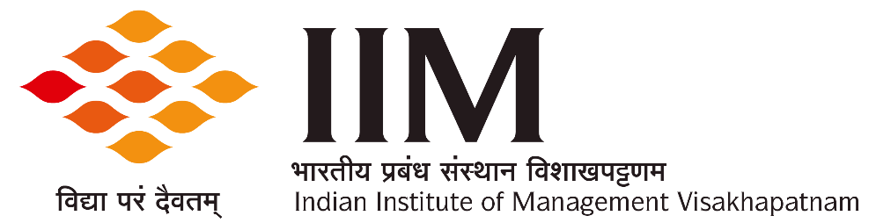
Andhra Bank School of Business Building, Andhra University Campus, Visakhapatnam:530003

Tel: +91 891 2824 444 | e-mail: pgpexadm@iimv.ac.in

November 25, 2021
Admission & Eligibility – PGPEx 2022
This document details the process that will be adopted for selecting candidates for admission to the Post Graduate Program for Experienced Professionals (PGPEx) at the Indian Institute of Management Visakhapatnam (IIMV) for the batch of 2022.
The admission process seeks to identify the most promising candidates for the PGPEx batch of 2022 for IIMV. IIMV uses multiple parameters, namely past academic performance, work experience, candidates’ scores in an entrance examination, as well as performance in Personal Interview to judge the suitability of candidates for the PGPEx program. Evaluation by multiple criteria is also consistent with empirical research on recruitment and selection that shows greater efficacy of recruitment processes that uses multiple criteria. Such multiple criteria are used to arrive at a composite score for every candidate, which is used to select candidates. The remaining part of the document explains this process in detail.
Eligibility Criteria
The eligibility criteria for admission into the Program are as follows:
- The applicant must hold a bachelor’s degree (minimum 55% marks or equivalent) that has been recognized by an authorized body in India. The Bachelor's degree obtained by the candidate must entail a minimum of three years of education after completing higher secondary schooling (10+2) or its equivalent.
- The applicant must have a minimum of three years of full-time work experience as on May 16, 2022 at an officer/executive level or higher; as a professional or as an entrepreneur. Part time work experience, clerical (non-officer/ non-executive) experience and apprenticeship will not be considered as eligible work experience.
- Applicants require a valid CAT, GMAT, GRE score to be considered for admission.
- Alternatively, applicants also can choose to apply for PGPEx by opting to take IIMV Test.

Application Process
The application form for admission to PGPEx (2022-24), will be available at https://www.iimv.ac.in/program/prg-pgpex-application-form
A non-refundable application fee of INR 1000/- is to be submitted along with the application. SC, ST, PwD, Women applicants are totally exempt from paying the application fee. NC-OBC and EWS applicants are required to pay 50% of the fee viz. INR 500/-.
Candidates those opting to appear for the IIMV Test will have to pay a non-refundable fee of INR 1000/- in addition to the application fee. There is no discount for any category of applicant in the IIMV Test fee.
Application fee and IIMV Test fee (both non-refundable) as mentioned above, should be paid online through the ‘Online Fee Payment’ SBI link in the Institute’s website https://www.iimv.ac.in (please go through the Online Fee payment Instructions under Admissions tab --> PGPEx Program --> Application form on IIMV website).
IIMV test will be an Online Proctored base test.
Applicants are required to ensure that the following documents are submitted along with the application form. It is emphasized that the application form will be considered to have been completed only upon submission of all the following documents. Incomplete applications and/or applications not adhering to the requirements specified herein are liable for rejection.
Documents to be submitted:

- Copy of Government issued Photo Identity proof (Driving License, Passport, PAN Card, Aadhar etc.,)
- SSC, HSC & Bachelors’ Degree Transcripts or Mark Sheets
- Bachelor’s Degree Certificate
- Master‘s Degree Certificate (if applicable)
- CAT / GMAT / GRE Score Sheet (if applicable)
- Statement of Purpose (SOP, not exceeding 800 words) for pursuing the PGPEx program
- Work Experience letters / Last Pay-drawn Certificates (LPCs) / Authenticated Salary Slips (First & Last) - indicating Date of joining, Date of leaving (if any) and duration of service. The work experience letters, LPCs or the Salary Slips, as the case may be, would be required for each of the employment positions served by the applicant)
- Copy of caste / disability certificate (SC / ST /NC-OBC /PwD / EWS) — if applicable.
It may be noted that:
- NC-OBC certificate is valid for one year from the date of issue; Applicants must ensure that they submit a valid certificate (valid till July 2022).
- The PwD certificate must be issued by a Government hospital signed by a panel of three doctors or by a Chief Medical Officer (CMO) as per the PwD Act 2016.
- EWS certificate must be issued by an officer of the rank of Tehsildar or above.

Selection Process
- Applicants will be short-listed based on their performance in CAT/ GMAT/ GRE/ IIMV Test, as chosen by the candidate, performance in the prior qualifications, and duration of work experience.
- Shortlisted candidates will be called for a Personal interview. The interview panel will evaluate each candidate's performance based on such factors/parameters as SOP, diversity, general awareness, leadership qualities, accomplishments at workplace, etc.
- At the time of the interview, employed candidates will be required to produce a “No Objection Certificate” from their employers.
- Final selection will be made based on a composite score comprising the performance in the Admission Test, nature and extent of work experience, SOP and Interview.
- The composite total score will be calculated using a multi-factor model.
The admission offer will be made to a certain percentage of applicants depending on the availability of seats and their satisfying a minimum cut-off on the composite score.

The information in this document is applicable only for the admissions cycle PGPEx - 2022 of IIM Visakhapatnam and therefore, no inference can be made from this document about the admissions process that will be used for future admission cycles at IIMV. The Institute (IIMV) reserves the right to change, modify or adopt any new admissions process that it deems necessary, at any point.
Any dispute concerning Admissions for the PGPEx Batch 2022-24 would be subject to jurisdiction of the competent courts within the territorial jurisdiction of city of Visakhapatnam only.

